**Lab 2.** **Managing Ambari Users and Groups**

**Adding Ambari User Accounts**

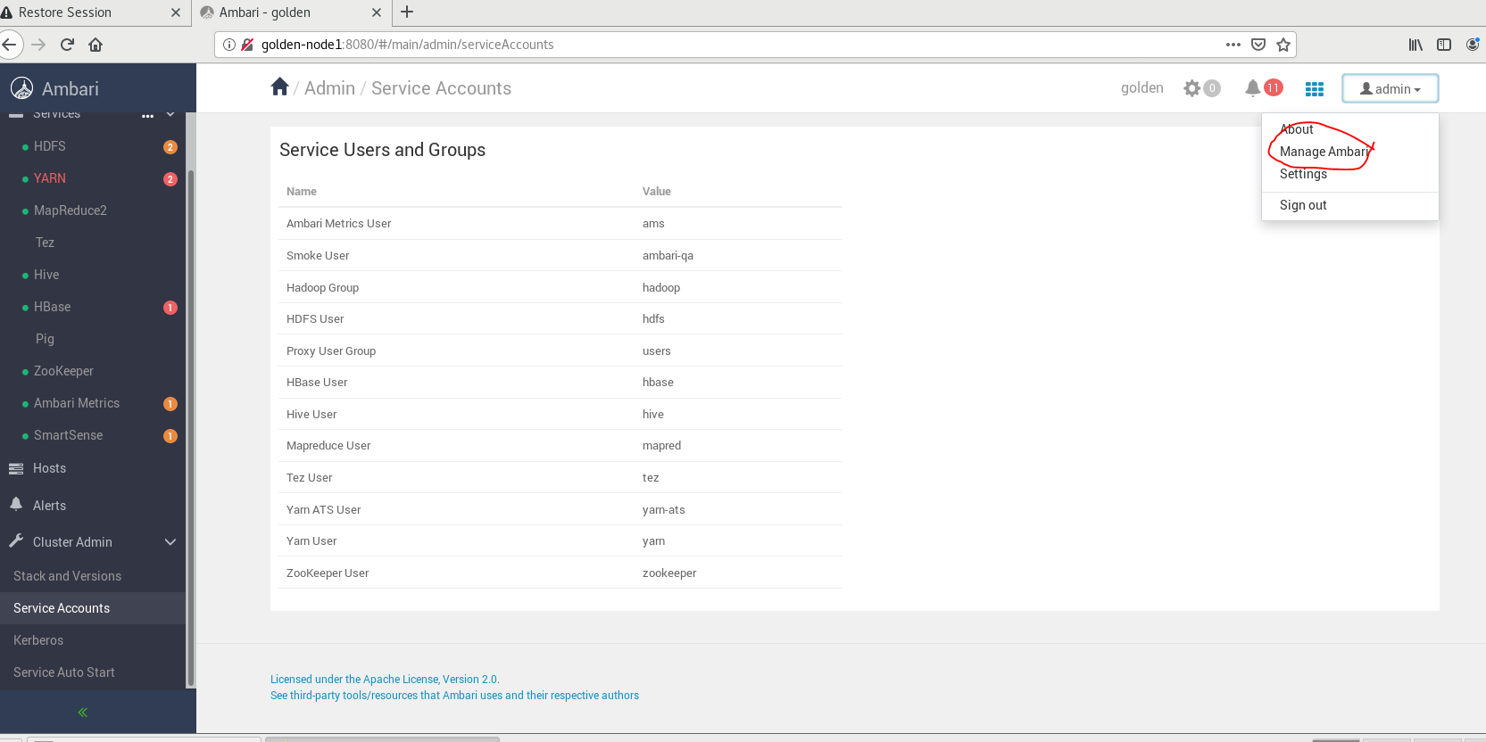

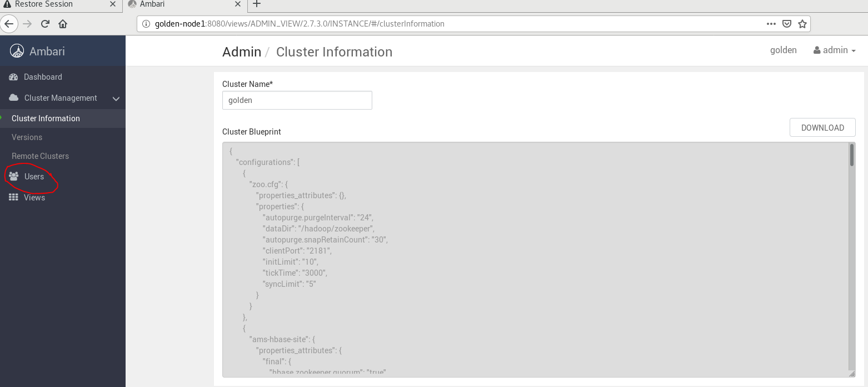

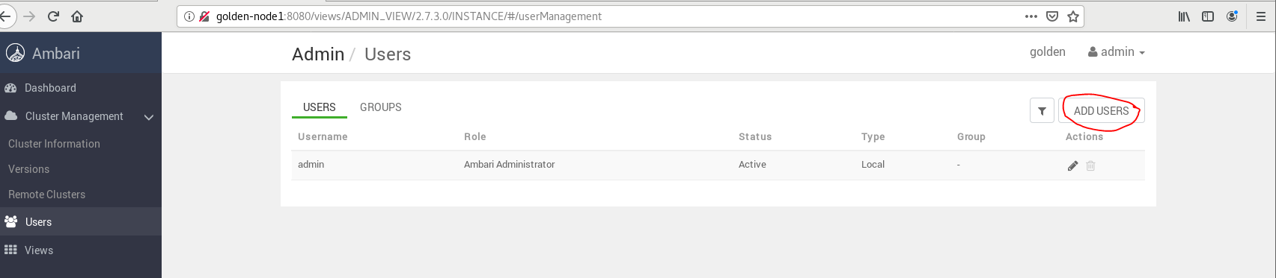

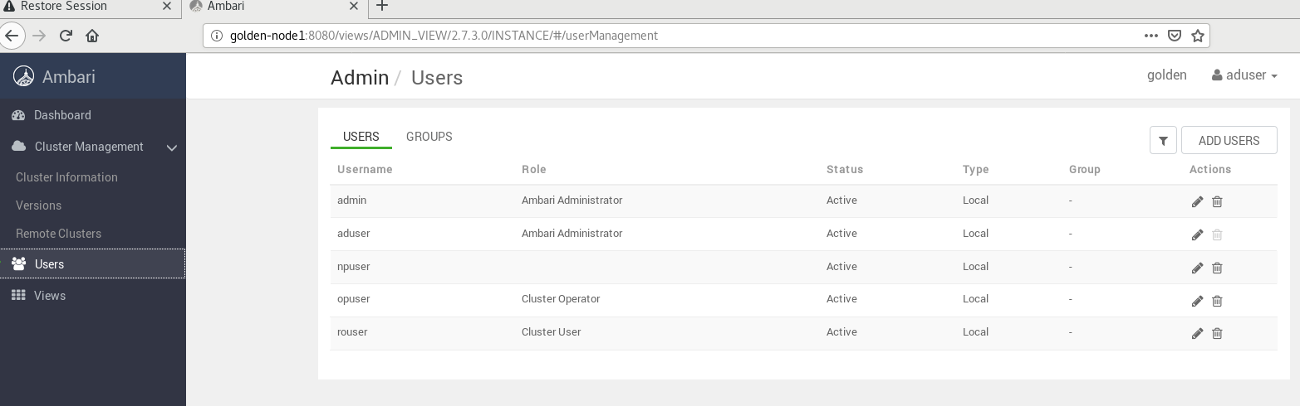

**Creating Group**

